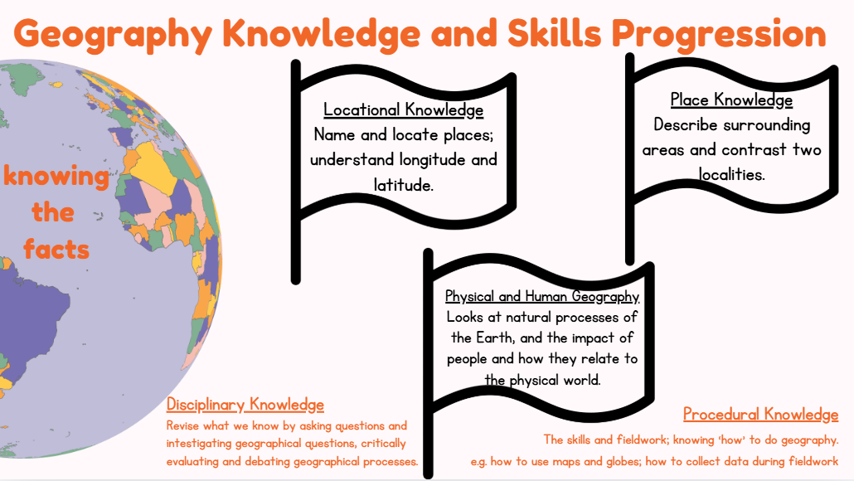

Year 2/3 (B)
The World
Europe
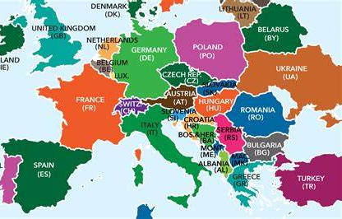
Year 2/3 (A)
Physical Features
Rainforests
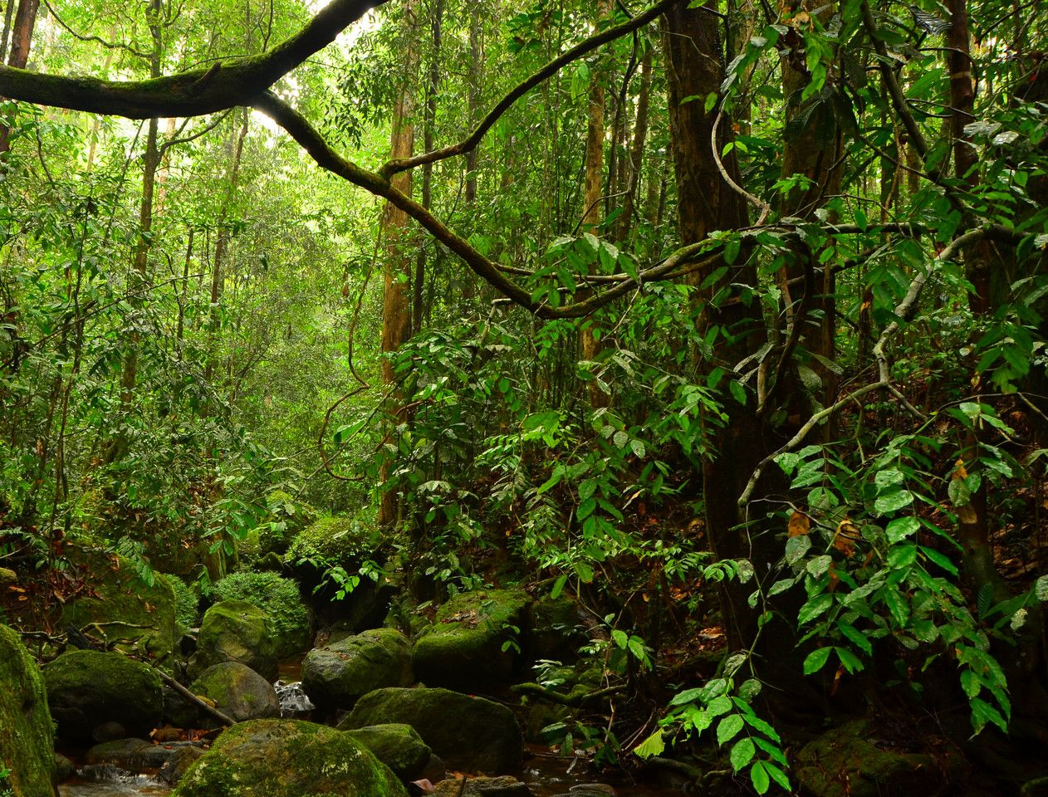
Year 2/3 (A)
Physical Process
Islands
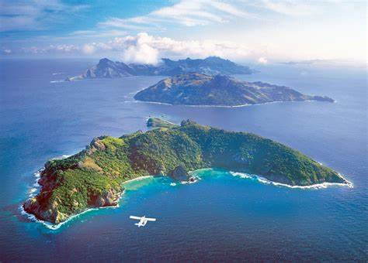
Year 2/3 (B)
The 7 Continents
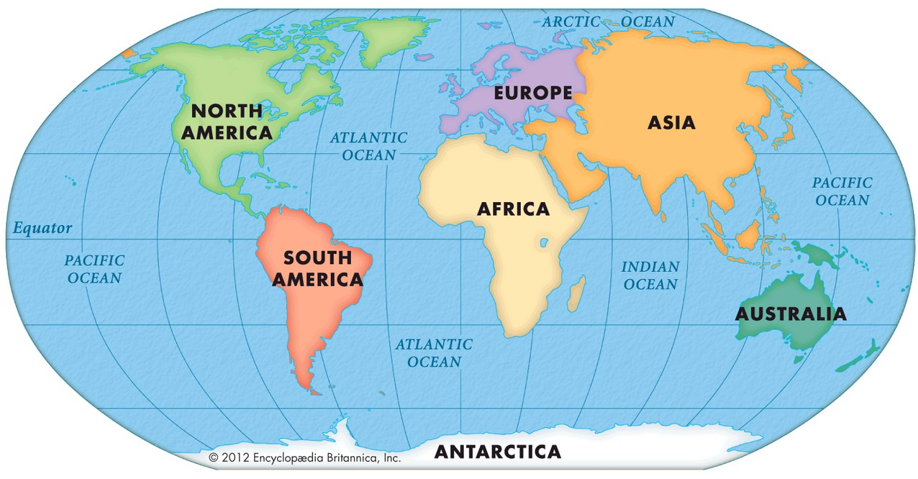
- – Cycle A school year
- – Cycle B school year
Year 2/3 (B)
Settlements and
Land Use – London

Year 2/3 (A)
Contrasting
Locality
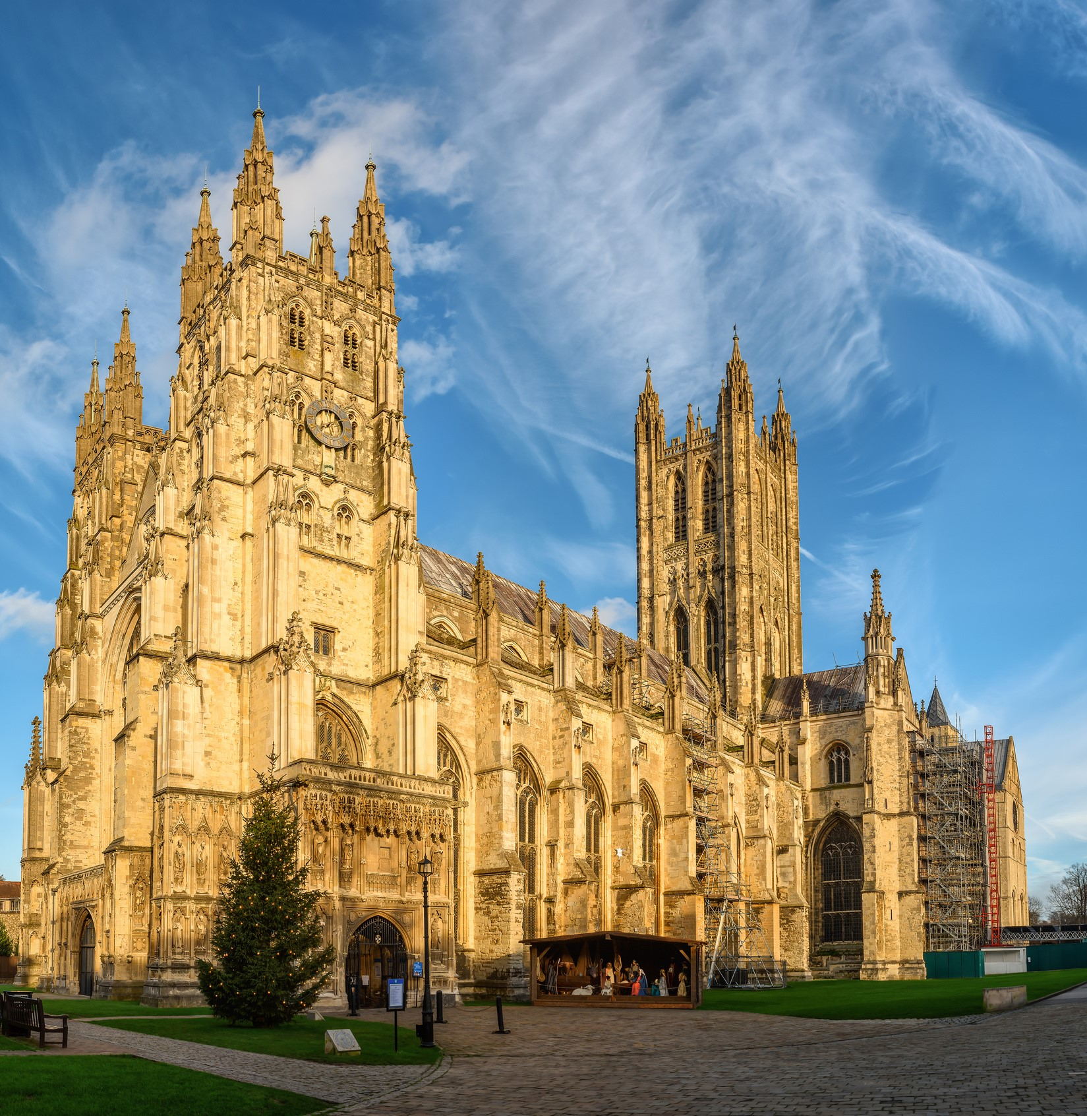
EYFS
Local area
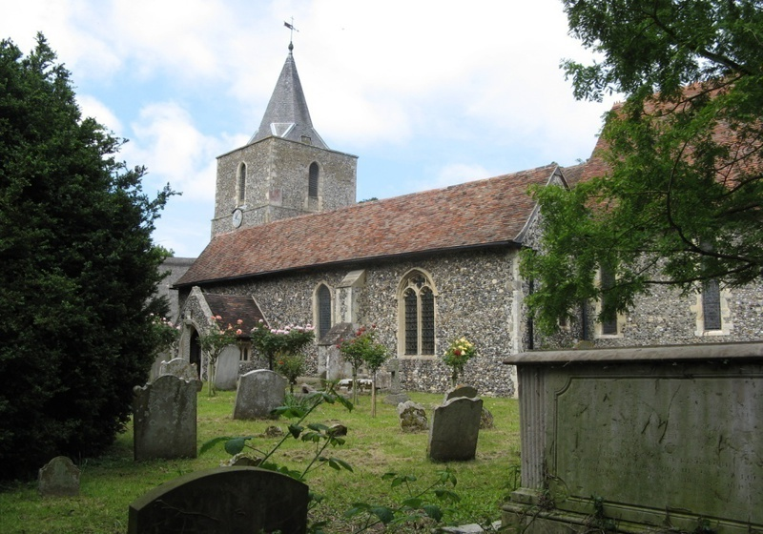
Year 1
Local area
Year 1
The UK
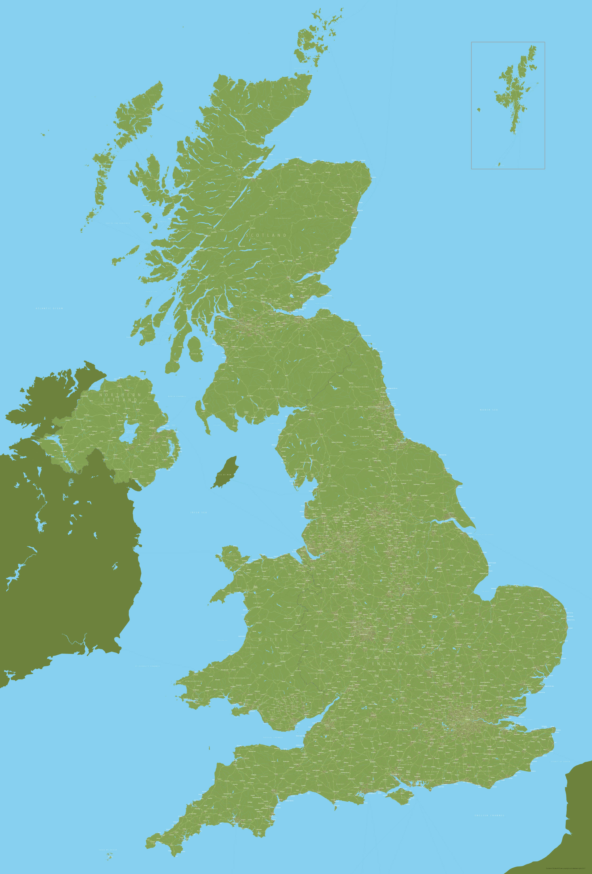
Year 1
Comparing climates and weather
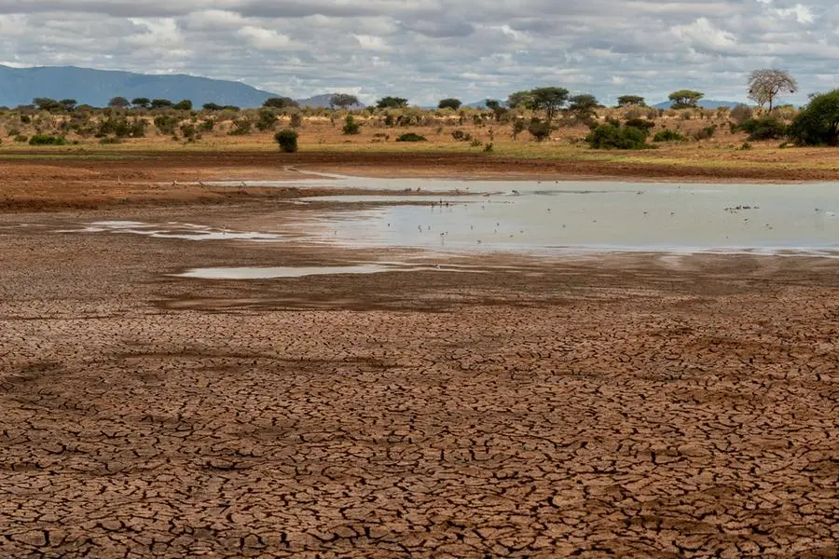

KS1 Geography Pathway

- – Cycle A school year
- – Cycle B school year
Year 4/5 (B)
Trade and Resources

Year 6
Comparing Climates
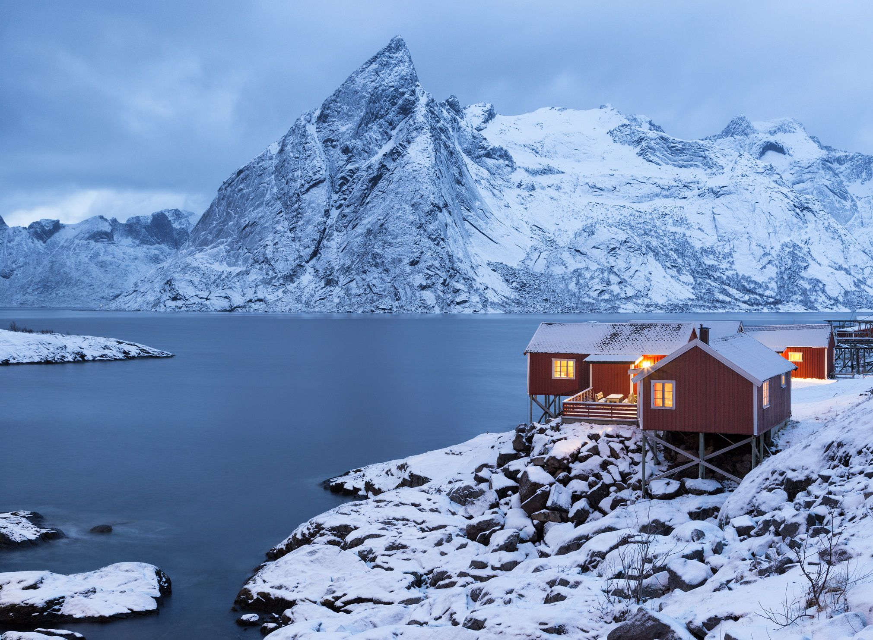
Year 6
Biomes
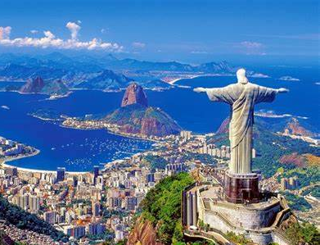
Year 6
Sustainability
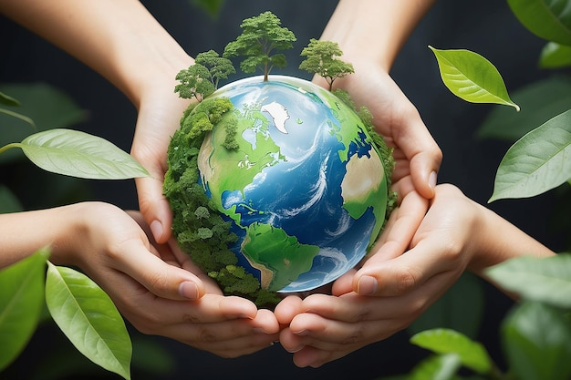
Year 4/5 (B)
The world
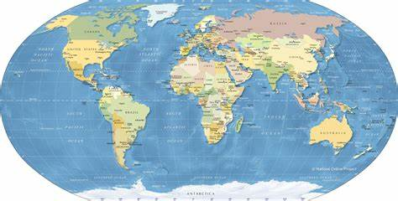
Year 4/5 (A)
Settlements
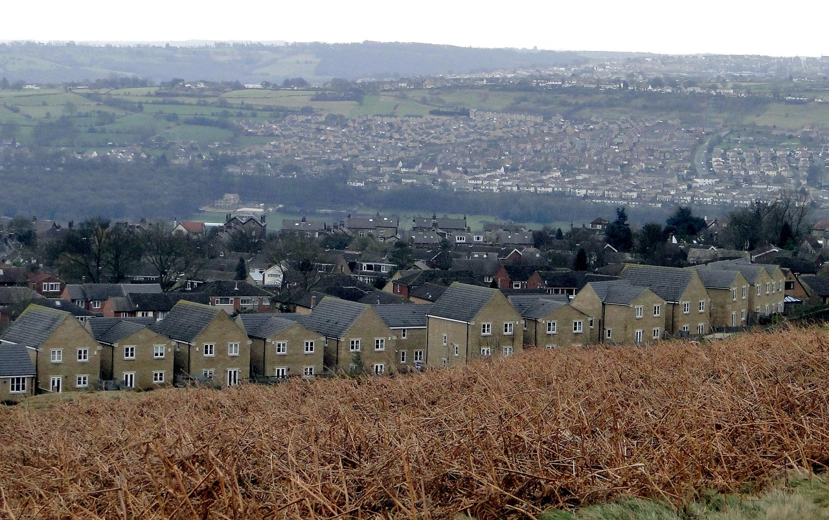
Year 4/5 (B)
Weather & Climate
Water cycles
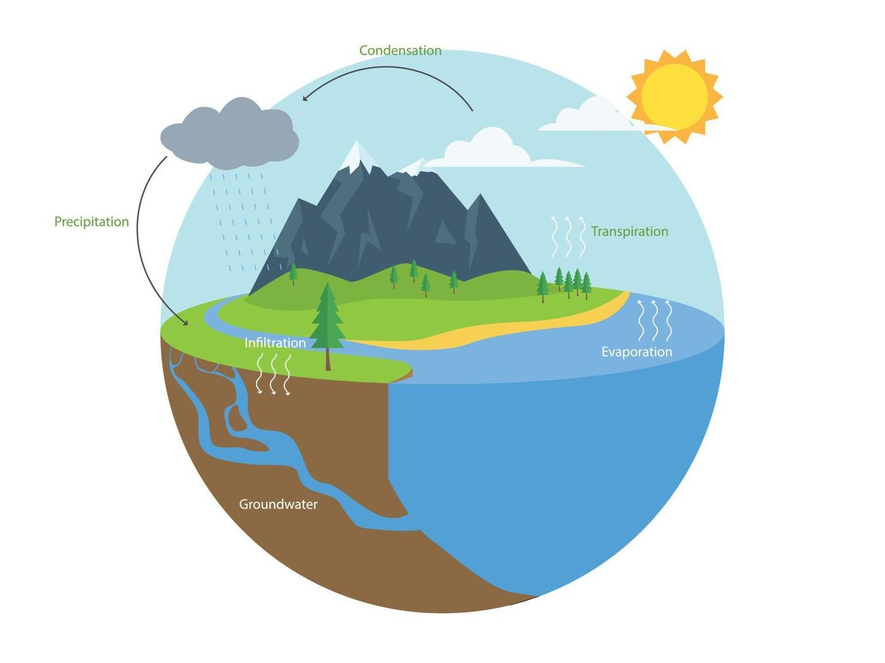
Year 4/5 (A)
Physical Process
Mountains
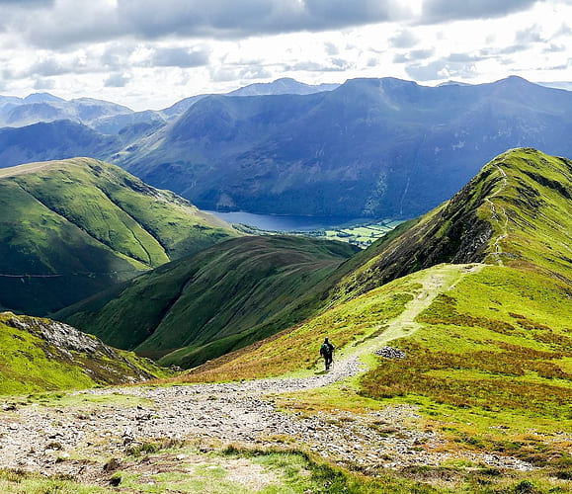
Year 4/5 (A)
Physical Process
Volcanos
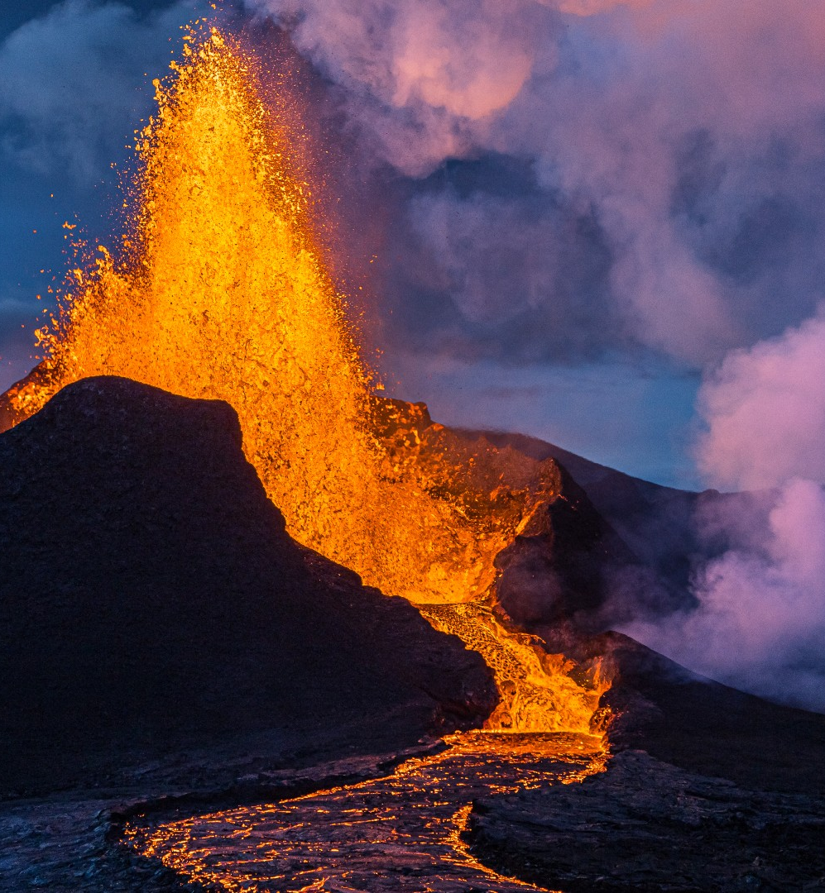
KS2 Geography Pathway

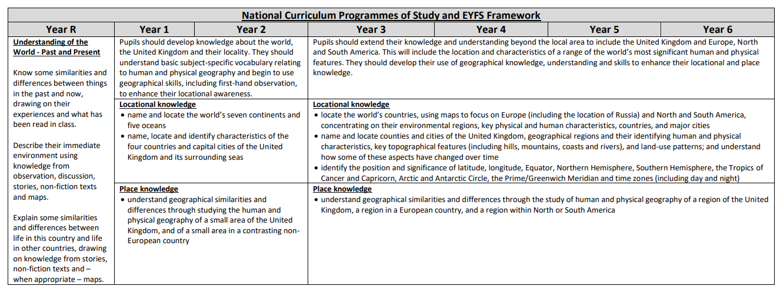

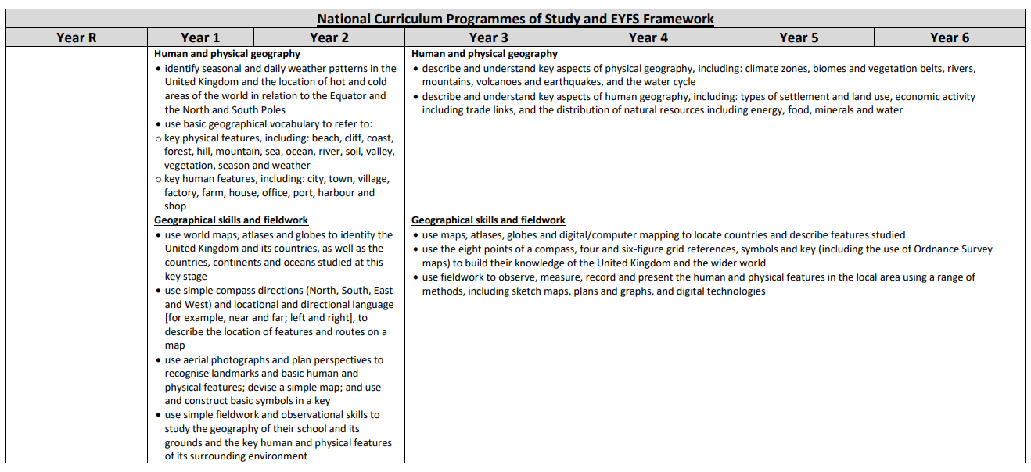

Yearly Progression of NC Knowledge, Skills and Understanding - SUBSTANTIVE KNOWLEDGE
Geography Skills, Fieldwork - Procedural knowledge
 | Reception | Year 1 | Year 2/3 | Year 4/5 | Year 6
World maps | Locate chosen country/countries of parental heritage on globes/maps. To identify the land and sea on world globes/maps. | Draw and locate the  UK and  oceans on globes and world  maps or atlases. | Draw and locate the  locations of continents, countries and oceans on globes and world maps or  atlases. | Use maps, atlases, globes, Google Maps and Google Earth to locate mountains, mountain ranges, volcanoes (in relation to tectonic plates) and different settlements of the world. | Use physical and political maps, atlases, globes, Google Maps/Earth to locate and describe studied human/physical features of North/South America, including countries, land use, settlements, mountains, coasts, seas, lakes, rivers, climate & temp.
UK maps | Locate England on a simple map. | Draw and locate the four countries of the UK on a UK map or atlas. | Draw and locate the four countries of the UK, their capital cities, some of other major cities and the surrounding seas on a UK map or atlas, using the four main compass directions. | Use the eight points of a compass, four figure grid references, paper maps, Google Maps, Google Earth, symbols and keys (including the use of Ordnance Survey maps) to locate and describe human and geographical features studied, including rivers, mountains, hills, towns and cities, landmarks and varied climates. | Use the eight points of a compass, six figure grid references, maps, symbols and keys (including the use of Ordnance Survey maps) to identify and describe human and physical features of a region of the UK when comparing with regions of North and South America.
Local/Regional  Maps and  Other  Secondary  Data Sources | Begin to use simple locational/directional language (e.g. near, far, up, down, forwards and backwards) to describe the location of features on a local map and to move around the school. | Begin to use simple locational/directional language (e.g. near, far, up, down, left, right, forwards and backwards) and the four main compass directions (North, South, East and West) to describe the location of features on a local map and to move around school. Construct simple plans with support. Use aerial images to recognise basic and human physical features. | Use simple locational/directional language and the four main compass directions (North, South, East and West) to describe the location of features on a local map, and follow/create a route in the local area. Construct simple maps. Use aerial images to recognise basic physical and human features. | Use locational/directional language, the 8 points of a compass, 6-figure grid references, maps with keys (inc the use of OS maps) and Google Maps/Earth to identify and describe changing local land use over time. Create detailed maps and label physical features. Use aerial images and age-appropriate graphs to acquire and discuss geographical information. | Use the eight points of a compass, six figure grid references, maps with keys and Google Maps/ Earth to describe geographical features of locations in North/South America, and create a tourist route. Create detailed maps and label human features. Use aerial images and age-appropriate graphs to acquire and discuss geographical information.
Local Fieldwork | Begin to use observational skills to draw simple plans and routes around their classroom, school, and local area. | Begin to use simple fieldwork and observational skills to study the geography of the classroom and local area (e.g. note taking, videoing, taking photos, data collection, sketches, observations, and labelled maps and photos of roads, parks, nature spots, rivers, shops and buildings. | Use simple fieldwork and observational skills to study the human and physical geography of the school, its grounds and the local area (e.g. note taking, videoing, taking photos, data collection, sketches, observations and labelled maps and photos of: roads, parks, nature spots, rivers, shops and buildings), suggesting reasons for the causes of similarities and differences. Carry out a simple survey of the school or local area (e.g. weather, traffic). | Use fieldwork to observe, measure, record and present the human and physical features in the local area using a range of methods, including annotated sketch maps, plans and graphs, and digital technologies. | Use fieldwork to observe, record, present and explain information about the changing locality using a range of graphs and written media, including population data, use of land in the school locality (e.g. classification of buildings into residential, commercial, industry, leisure, public buildings etc), and comparisons with old maps and photographs.

Disciplinary Knowledge
 | Reception | Year 1 | Year 2/3 | Year 4/5 | Year 6
Asking and Answering Questions | Ask questions about aspects of their familiar world. | Ask and respond to geographical questions. | Ask and respond to geographical questions. | Ask and respond to geographical questions using evidence to support answers. | Ask and investigate geographical questions, suggesting enquiries to test them.
Collecting and Interpreting | Draw things they see around them. | Observe and collect information and data from fieldwork, photos and aerial images, diagrams, globes, atlases and simple maps and charts. | Observe and collect information and data from fieldwork, photos and aerial images, diagrams, globes, atlases and simple maps and charts. Understand that geographers learn about the world by observing and collecting data and information. Begin to understand that some knowledge about the world can be revised as we collect new data and information | Observe and collect information and data from  fieldwork, photos and aerial images, diagrams, globes,  atlases, maps, GIS and a range of age-appropriate  charts and graphs, choosing an appropriate method to  record evidence as needed. | Observe and collect information and data from fieldwork, photos and aerial images, diagrams, globes, atlases, map, GIS and a range of age-appropriate charts and graphs, choosing an appropriate method to record evidence as needed and provide reasons for this.
Analysing and  Communicating | Communicate simple geographical information with support, orally, using simple pictures, maps and through writing. | Analyse and communicate geographical information by constructing simple maps, labelled diagrams, age appropriate graphs and through writing, using appropriate geographical vocabulary. | Analyse and communicate geographical information by constructing maps with keys, labelled diagrams, age appropriate graphs and through writing at length, using appropriate geographical vocabulary. | Analyse, communicate and explain geographical information by constructing maps with keys, labelled diagrams, age-appropriate and through writing at length, using appropriate geographical vocabulary. Choose an appropriate method to communicate information and give reasons for this. | Analyse, communicate and explain geographical information by constructing maps with keys, labelled diagrams, age-appropriate and through writing at length, using appropriate geographical vocabulary. Choose an appropriate method to communicate information and give reasons for this.
Evaluating and Debating | Describe their immediate environment and express their views about it, with support. | Express their own views about the people, places and environments studied. | Express their own views about the people, places and environments studied, giving reasons. Compare their views with others. Reach geographical conclusions and begin to debate the impact of geographical processes and human effects on the world, from given evidence. | Express their own views about the people, places and environments studied, giving reasons. Compare their views with others and understand that some geographical knowledge is open to debate, challenge and discussion. Reach geographical conclusions, give reasons and critically evaluate and debate the impact of geographical processes and human effects on the world, from given evidence. | Express their own views about the people, places and environments studied, giving reasons. Compare their views with others and understand that some geographical knowledge is open to debate, challenge and discussion. Reach geographical conclusions, give reasons and critically evaluate and debate the impact of geographical processes and human effects on the world, from given evidence.

